

From Parish

to Partnership

Developing new partnership arrangements in the

Diocese of Hexham and Newcastle





*‘The parish is not an outdated institution*

*precisely because it possesses great flexibility;*

*it can assume quite different contours*

*depending on the openness and missionary creativity*

*of the pastor and community’.*

Pope Francis, *Evangelii Gaudium*

1 From Parish to Partnership

*This section explains the thinking behind Area Partnerships and explores what they could be like.*

**1.1 Background**

The aim of *Forward Together in Hope* is to help ensure that we have viable, flourishing and outward-looking worshipping communities in every part of our diocese that are sustainable into the future. As the *Forward Together in Hope* journey has progressed, there are some very clear messages emerging about how we might best achieve this. One significant and very common theme coming through loud and clear from parish questionnaires and from listening to the views of lay people and clergy alike is the benefit of strong collaboration and partnership with our neighbouring communities. This leads us to the conclusion that developing new partnership arrangements across the whole of our diocese is an important next step on the road we are travelling together.

The entire *Forward Together in Hope* process is firmly rooted in prayer and a real openness to the guidance of the Holy Spirit. Its success depends on all of us playing our part in thinking beyond the limits of our experience and imagining new possibilities. We currently have 150 parishes and 18 deaneries. The only boundary that cannot be changed is the diocesan boundary (we are not likely to interfere with the Tweed, the Tees, the Pennines and the North Sea.) Other than these constraints, all possibilities are capable of exploration.

In *Evangelii Gaudium*, paragraph 23, Pope Francis encourages us to think differently and creatively:

*‘The parish is not an outdated institution precisely because it possesses great flexibility; it can assume quite different* ***contours*** *depending on the openness and missionary creativity of the pastor and community’.*

This could be an invitation to every one of us in the diocese to become more open and missionary in our vision for the future.

Some people may wonder whether this partnership approach is different from what has happened previously in relation to ‘Clustering’. There are three very significant differences:

* This programme is happening in every parish in the diocese at the same time. While some other dioceses are looking at developments deanery by deanery or town by town we are attempting to explore the issues in every parish community simultaneously.
* ‘Clustering’ looked at parishes working together in relatively close proximity. Our approach is inviting imagination beyond the immediate. It is open to very different parish and deanery boundaries. This freedom of imagination is necessary if we are to explore how people will be served - initially in 5 and 10 years’ time and then up to 2030 and beyond.
* By July 2017 there will be a ‘Flexible Partnership Plan’ envisaged for the diocese. It is inevitable that every parish in the diocese will be involved in some way.

The purpose of this document, *From Parish to Partnership* is to help each of our existing parish communities to prepare for detailed discussions with their neighbours later this year. We expect that the fruits of these discussions will include clear ideas about how these new partnerships will be formed and how a partnership arrangement in your area would work in practice.

**1.2 Some Benefits of Partnerships**

It is becoming increasingly clear that closer collaboration between parishes across a geographical area has many benefits. These include, for example:

* The sharing of the skills, talents and human resources of a wider group of clergy and lay people.
* The potential for larger events and long-term collaborative activities than might be possible for one parish to undertake (e.g. a shared approach to outreach work, area-wide strategies to engage young people, social events across the whole partnership etc.)
* The development of viable and sustainable communities and stronger support networks.
* Efficiency savings in terms of buildings maintenance, purchasing, administration etc.

Most importantly, the development of these partnership arrangements is a key aspect of helping to ensure that we are all disciples of Jesus in viable and flourishing communities into the future.

**1.3 Geography and Size of Partnerships**

The geographical coverage and number of parishes in a partnership are likely to vary depending on local circumstances. For example, rural and urban areas will have different issues to consider and some parishes already cover large geographical areas and include several churches.

However, regardless of the local circumstances, it is important to remember that these new partnership areas need to be sufficiently large to ensure that they are viable well into the future. To achieve this, given the projections of the number of priests and people in the years ahead, we will need to think bigger than partnerships with two or three neighbouring communities. It is anticipated that in the majority of cases partnerships will include at least 5 or 6 of the existing parishes – and maybe many more.

**1.4 How Area Partnerships Could Look**

The Area Partnership approach requires good communication and collaboration at all levels of the partnership. We imagine that a strong team of clergy and lay people would be established to co-ordinate this across the area. We wouldn’t wish to be prescriptive about the membership and remit of such teams but you may like to consider the following:

***Who might be involved in a partnership leadership team?***

In most cases we would envisage that a leadership team might include all of the priests and deacons in the partnership area and lay people with a good mix of skills, knowledge and experience across the facets of parish and school life. Locally there may be other key people who could be involved and this is very much part of what partnership areas will be asked to think about. The geographical coverage of the partnership needs to ensure that the ideas and concerns of individual communities are heard. Membership of existing groups and structures may provide a useful starting point but fresh thinking is important too.

***What might be the remit of an Area Partnership?***

The team would have a shared responsibility for co-ordinating and developing the Partnership Area’s activity on a wide range of fronts, perhaps including:

* A shared approach to developing and deploying Catechists, Musicians, Funeral Assistants, Extraordinary Ministers of Holy Communion, Lay Leaders of Celebrations, Marriage Preparation, RCIA etc.
* Stewardship - maximising the use of buildings and other facilities, sharing Health and Safety Officers etc.
* Exploring how the essentials of the pastoral and sacramental ministry of the priest might be supported
* Providing wide-ranging pastoral care with particular emphasis on the elderly, sick and housebound
* Contributing to chaplaincy arrangements in hospitals, prisons and workplaces
* Shared events and social activities to build up the community
* Outreach activities, whether with other churches or other faiths and whether at the end of the street or in other parts of the world
* Engaging with, enthusing and encouraging our young people
* Financial Management
* Looking to ensure that Sunday Mass is accessible to as many people as possible with a variety of Mass times in the area

…and probably many other aspects.

This is not a comprehensive list and it is not intended to be either prescriptive or restrictive. While the overall approach will be similar in each part of the diocese the model requires flexibility to be able to cope with the variety of situations which exist - rural or urban, financially well-off or struggling, predominantly older worshippers or many young people etc.

**1.5 The Standing of an Area Partnership**

Individual parishes have a range of requirements and responsibilities in relation to finances and administration some of which are defined under Canon Law, Charities Law and other legislation. These would not be altered by the development of Area Partnerships. In some areas it may be desirable for parishes within a partnership area to merge over time and, should this happen, the above responsibilities would be taken on by the new parish entity.

In essence, the Partnership is there to support and co-ordinate arrangements and develop collaborative approaches across its area. Ultimately it is about helping everyone to fulfil their call to become stronger disciples within flourishing worshipping communities.

**1.6 Developing and Submitting an Area Partnership Plan**

Bishop Séamus has indicated that *Forward Together in Hope* is to be an open and transparent process throughout. This ambition becomes even more important as we move into the stage of developing Area Partnerships and associated Partnership Plans. Please start to consider ways to ensure as much discussion, consultation and awareness among as many people as possible as we move towards developing proposals for these new arrangements.

***Section 2*** below sets out the areas that we feel it is important to start to consider in relation to establishing new partnerships. During the summer we will provide more detailed information about what will be required when communities in every part of the diocese are working with their neighbours to prepare Area Partnership Plans.

The deadline for submitting these plans is the beginning of Advent (27th November 2016). We cannot guarantee that any plan received after that date will be included in our deliberations as we need to be in a position to collate all of this and to present recommendations to Bishop Séamus and the Diocesan Board of Directors ahead of their residential meeting in January 2017.

**1.7 Bringing Everything Together**

It is really important to remember that plans submitted at the end of November present a Partnership Area’s *initial proposals*. Once they are all received, these proposals have to be brought together to arrive at a position that works well across the diocese as a whole. While this is likely to mean that some proposals will not be accepted in their entirety, we will ensure that all of your thoughts and ideas are brought to bear on the recommendations put forward to Bishop Séamus and the Diocesan Board.

Once decisions are made, the partnership areas will be formalised and each area asked to commence detailed planning and implementation.

**2 Developing an Area Partnership**

*This section sets out the type of information that will be expected in an Area Partnership Plan and provides an indication of the issues you might start to consider.*

By the beginning of September we will provide more detail about how we would like parishes to present their proposals in relation to Area Partnerships. This will include a short template for producing an Area Partnership Plan addressing various aspects of the proposed partnership and the approach you’ve taken in consulting about it.

Even before we have finalised all the details of this we felt that it was important to provide you with enough information about the type of things an Area Partnership Plan will cover to allow you to start to think, pray and consult about it. The headings below raise many of the issues that will be included within the questions in the template.

**2.1 Details of the Proposed Partnership**

* We would like you to consider ***which of the existing parish communities in your area should work together*** in the proposed partnership.
* You might also think about ***whether there are alternative combinations*** that could work well.
* We would like you to arrive at a position where you are able to ***describe why the preferred grouping is the most appropriate*** for your area and whether there are any ***issues that might get in the way of effective collaboration***.
* Ideally, we would hope that there is a high level of agreement between the parish communities about the proposed partnership arrangement, though this may not always be the case. We will ask you to indicate how much agreement there actually is and how this has been arrived at.

**2.2 Working Collaboratively**

* Strong partnership requires strong leadership and co-ordination. It will be important to consider and discuss ***what leadership and co-ordination arrangements will be necessary*** in your proposed partnership. How a leadership team is put in place and supported will also be important. There may already be a lot of collaboration taking place between communities across the area that can be built upon. The proposed partnership will be asked to identify this as well as ***what new areas of collaboration are anticipated****.*
* Good communication will be critical in all of this so we will want you to consider ***how everyone in your proposed partnership area will gain a full awareness and understanding of the plans and developments.***
* When considering new arrangements across the area it may be relevant to discuss ***what resources you would need*** to ensure that the co-ordination works well. People often think about administrative support – but also think wider about how each of the facets of the partnership could benefit from co-ordinated voluntary or paid support and what training there might be.

**2.3 Structural Change**

* We will ask you in the plan you submit at the end of November to present any ***thoughts you might have for changing parish structures*** in your proposed partnership area. For example, you might want to start thinking about bringing together key groups, merging existing parishes or other possible changes to the structure.
* These aspects may well develop over time, so thinking about this over the short term (1-2 years), medium term (3-5 years) and the long term (up to 10 years) might be a helpful approach. It is more than likely that your ‘area’ will have at least one less priest in 5 years’ time and two less priests within 10 years from now.

**2.4 Facilities**

* We would ask that communities think about the existing places of worship within their proposed partnership area and ***what the arrangements across the partnership might look like in future****.* This could include using churches as well as other venues and would need to take into account the capacity of the buildings in relation to the expected size of congregations.
* 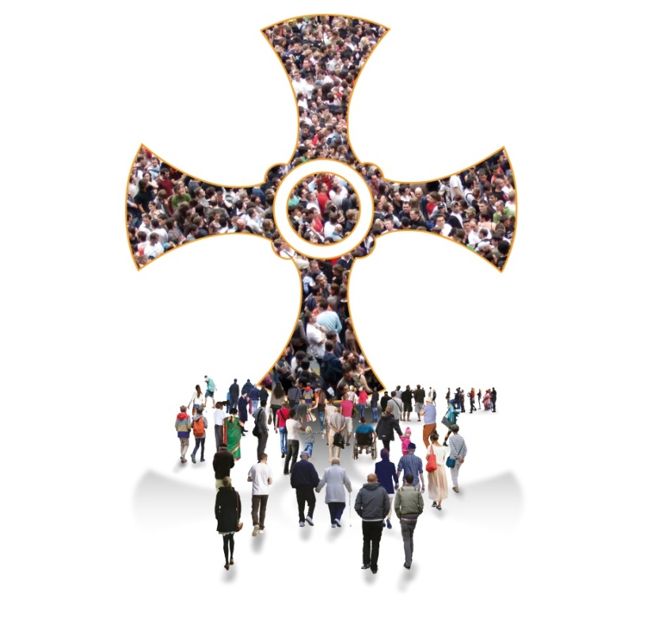In time it will be important to ***consider which church buildings will be retained for worship – and which might be closed or used for other purposes****.*

**2.5 Developing More Detailed Plans**

* Within the plans being presented in November we will be asking potential partnerships to provide a clear picture about ***what the most important next steps would be*** for your area should your outline partnership proposals be accepted by Bishop Séamus.
* We would also encourage you to think about ***the support that would be most helpful in achieving these next steps****.* Such support might be from within your current parish communities, from other partnership areas or from the diocese.

**2.6 Communicating and Consulting**

* The importance of consulting and communicating on these issues cannot be over-emphasised. It is vital that the Partnership Area Plan is fully informed by and shared with the whole community, so please make this process as inclusive as possible. When presenting your plans in November you will be asked for details of how you have approached the consultation, who has been involved and how they have been involved.
* Our Catholic primary and secondary schools have links with the worshipping communities in our parishes – as well as being worshipping communities in their own right. It is important that schools are invited to be part of the consultation and planning process.

**3 Working Through the Process**

*This section offers some initial ideas about how parishes and their neighbours might approach the process of developing proposals for an Area Partnership.*

**3.1 Open to the Holy Spirit**

Bishop Séamus has urged us to ensure that *Forward Together in Hope* is firmly rooted in prayer. During each stage of the journey it is important that we invite the Holy Spirit to journey with us, guiding us in our deliberations and inspiring us in our ideas and suggestions for the future.

**3.2 Informing and Engaging the Community**

A lot of information is being provided at this stage of *Forward Together in Hope*. It is all designed to inform and challenge us to do things differently as we start to put in place new arrangements. The details of the various items are presented in the accompanying booklet *‘Exploring the Way with Our Neighbours’*

A set of these documents has been made available to our priests, deacons and *Forward Together in Hope* representatives and all of the general information will be included on the website ([www.hope.rcdhn.org.uk](http://www.hope.rcdhn.org.uk)). We would encourage you to make people aware of these items through whatever means you can.

However, we know that much of this may well never be accessed by many of our parishioners, so we have produced a leaflet called *‘Imagine new ways…*’ and have provided it in sufficient quantities for everyone in the parish. The leaflet is seen as an important communication tool which presents some of the key points and encourages everyone to participate as fully as possible in the next steps of our journey.

Crucially, the leaflet also provides an opportunity for anyone to present their thoughts on some of the key issues by completing a ‘tear-off’. The idea is that whether or not people are able to attend meetings they have a way of contributing and being engaged in what is happening. For some people the leaflet will be the only information they will receive and so it is very important that they have the opportunity to receive a copy and are encouraged to respond.

**3.3 A Possible Approach**

As indicated earlier, in order to present Diocesan-wide proposals to Bishop Séamus in January 2017 we need to receive an outline Partnership Plan from each proposed partnership area by 27th November this year.

Communities will approach the task in different ways but you may find the following ideas helpful as a starting point:

* Establish the arrangements for planning and co-ordinating the activity. They may already be in place from previous *Forward Together in Hope* work. Some parishes have used their Parish Pastoral Council (or equivalent group) as well as *Forward Together in Hope* representatives. Some established a specific team to co-ordinate the task.
* Inform everyone as soon as you can about what will be happening over the next few months by providing and explaining the *‘Imagine new ways…’* leaflet to all parishioners at Masses or other gatherings. This will give people an overview of what will be happening and how they can contribute. Encourage them to offer their thoughts on Partnership and Leadership by completing the tear-off page. These can be considered by those planning and co-ordinating the activity and brought into discussion at an open meeting.
* It is suggested that at least one open meeting is held within your parish community between July and September to bring everyone up to date and engage them directly. The meetings have two main aims:

1. To present the *‘Observations’* that have been provided to each parish about their parish questionnaire along with the *‘A Profile of your Parish in Numbers’* document and to allow people to understand and reflect on them.
2. To discuss Area Partnerships and Lay Leadership and to seek people’s thoughts about how these might develop in the area.

* We have included a possible meeting format (Appendix 1) as a starting point for your thinking. This includes time for prayer, presenting information and discussing the key issues. Where it is possible to run two meetings, it may be appropriate to cover one of the above topics at each meeting to allow more time for each aspect to be considered.
* Not everyone will be able to attend the meetings but the views of everyone in the parish community, including the housebound, are important. Please use the usual communication channels and the *‘Imagine new ways…*’ leaflet to include and inform as many people as possible.
* After parish meetings have taken place, arrangements will need to be put in place for agreeing which individual parishes will be working together to develop the Area Partnership Plan. How this happens will vary a lot across the diocese and we will be depending increasingly on Deans and Episcopal Vicars to work with us and advise on how things are taking shape in each area. It may be necessary to take ‘soundings’ from each area as the process progresses in order to ensure that all parishes are covered in the partnership planning.
* During the Autumn, members of the *Forward Together in Hope Team* will visit each area (at Deanery or Vicariate level). We will meet with all priests, parish representatives, representatives from schools and any parishioners who wish to come, to explore how partnerships might look and develop and how we can explore lay leadership formation.

**Any Questions?**

As always, the members of the *Forward Together in Hope Team* are on hand to help in any way we can. If you have any questions at all about any of this please don’t hesitate to get in touch.

hope@diocesehn.org.uk

(0191) 243 3304 www.hope.rcdhn.org.uk



**Appendix 1: Possible Meeting Format**

|  |  |  |
| --- | --- | --- |
| **Activity** | **Who** | **Notes** |
| Welcome and Introduction | Chair | * Welcoming everyone * Setting out the purpose and timing of the meeting |
|  |  |  |
| Prayer and Reflection | Prayer Facilitator | * Using prayer and scripture to set the context and atmosphere for the meeting |
|  |  |  |
| Presenting the Observations and Parish Profile | Presenter | * Explaining the full range of information and survey reports available * Presenting an overview of the *Observations* and *Parish Profile* documents |
|  |  |  |
| What is this telling us? | Discussion Facilitator | * Introduction of the group exercise:   + *To look at the two key documents, to discuss these and provide any feedback* * Depending on the overall group size it may be appropriate to divide the full group into smaller groups (6-8 is probably the optimum size) and invite groups to consider particular aspects * Drawing out and summarising key points from the groups – possibly using flipchart to log these |
|  |  |  |
| From Parish to Partnership | Presenter | * Explaining the key aspects of ‘*From Parish to Partnership’* and that Area Partnerships will be developed in each part of the diocese |
|  |  |  |
| Partnership and Lay Leadership | Discussion Facilitator | * Introduction of the group exercise:   + *To consider how Area Partnerships and Lay Leadership might develop in the area including which neighbouring parishes might be involved in partnership arrangements*. * Drawing out and summarising key points from the group(s) |
|  |  |  |
| Consolidating and reflecting | Prayer Facilitator | * Taking the opportunity to reflect prayerfully on what has been discussed – possibly encouraging people to consider where they are personally in relation to this * Concluding with the *Forward Together in Hope* prayer |
|  |  |  |
| Thank you and next steps | Chair | * Thanking people for their contributions * Briefly setting the scene for the next stages/future meetings |

Diocese of Hexham and Newcastle, Department for Development and Renewal

Tel: (0191) 243 3304 E-mail: hope@diocesehn.org.uk Web: www.hope.rcdhn.org.uk

©Diocese of Hexham and Newcastle – June 2016

Also available in other formats

